Project 2- Solution

These are the steps we need to perform:

Step 1: Login to AWS Console and Choose Mumbai Region

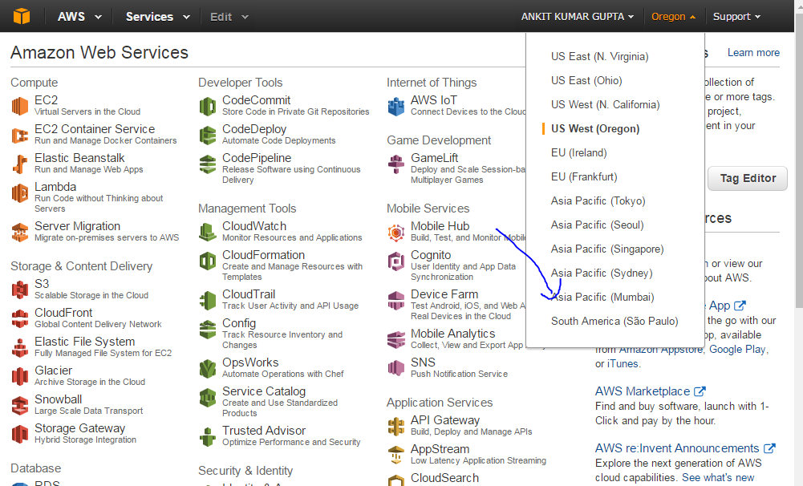

Step 2: Go to Amazon S3 Service and click on “Create Bucket”

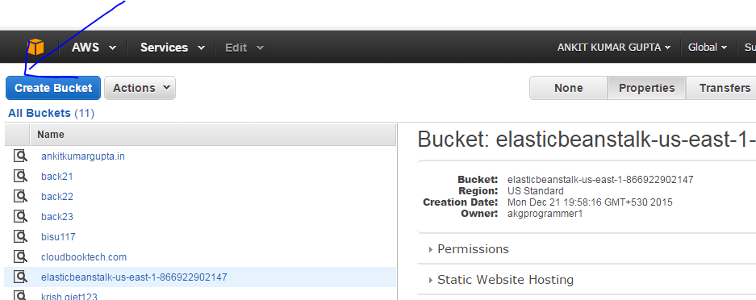

Step 3: Give the bucket name as “testoct28” and choose the region as “Mumbai” and click on create.

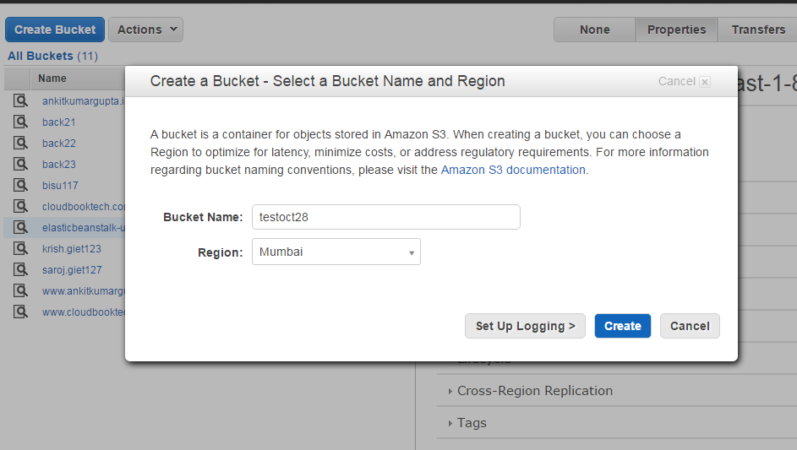

Step 4: Click on “Create Bucket” again, and give bucket name as “testoct28log” and region as “Mumbai” and then click on create. Both the Buckets have been created.

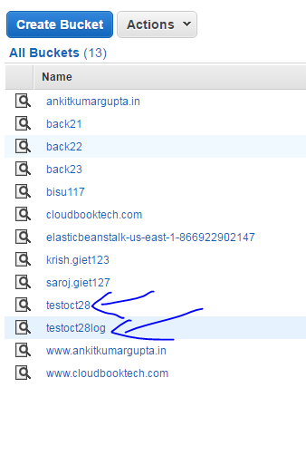

Step 5: Double click on Amazon S3 Bucket “testoct28” and click on “Upload” tab. Then click on “Add Files” option.

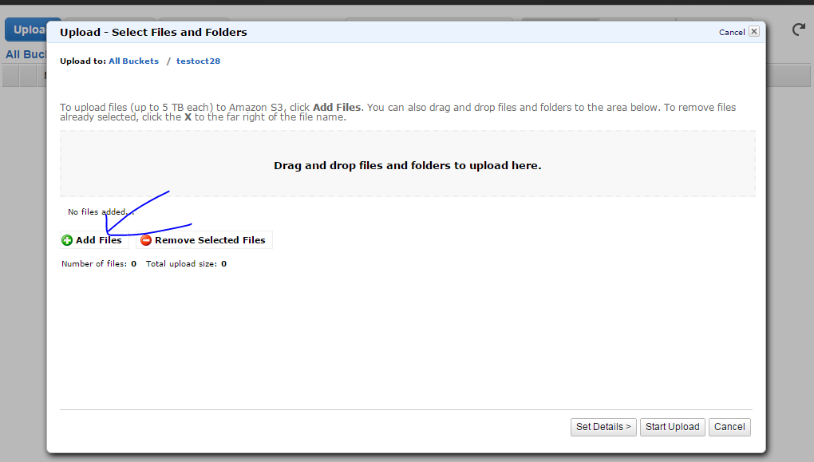

Step 6: Upload any Document and Click on “Start Upload”

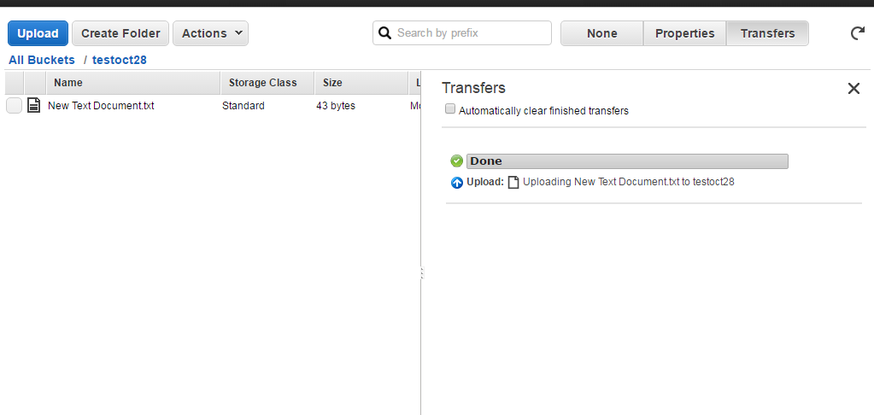

Step 7: Go to the Amazon S3 Bucket “testoct28” and click on “Properties” tab.

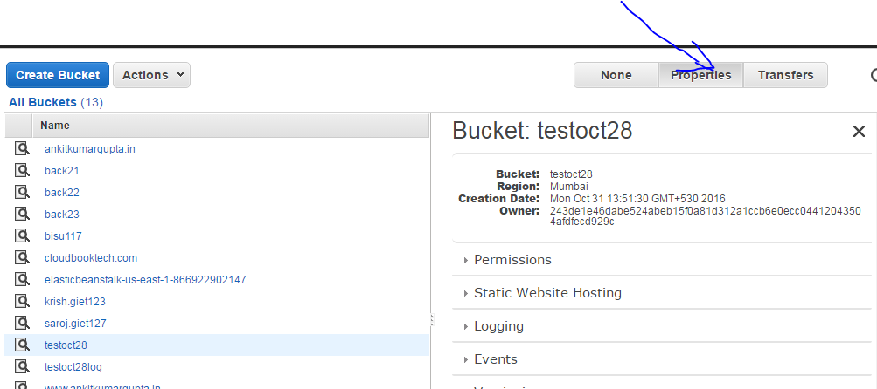

Step 8: Click on the “Logging Tab” and check the “Enabled” option. Specify the target bucket of the log as “testoct28log” and then click on the Save Option.

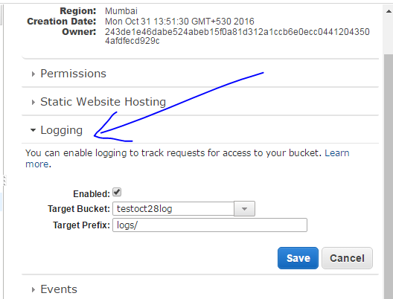

Step 9: Go to the “Versioning Tab” available in the Properties of Amazon S3 Bucket “testoct28”. Then Click on “Enable Versioning”

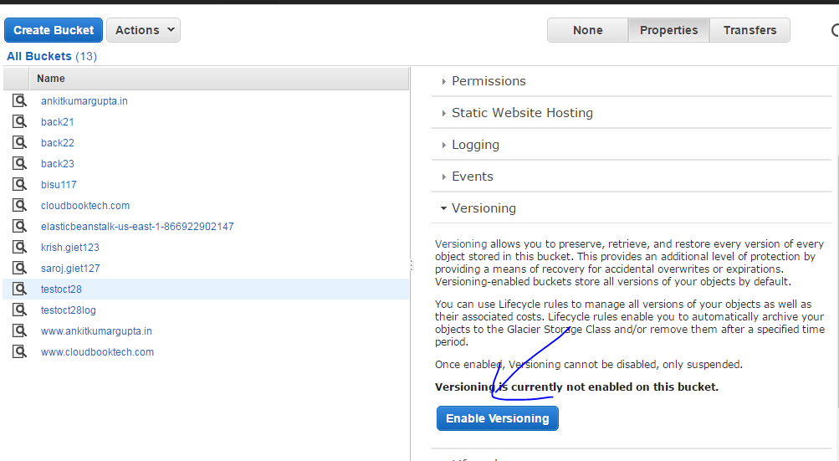

Step 10: Go to the “Transfer Acceleration” tab available in the Properties of Amazon S3 Bucket “testoct28”. Then Click on “Enable.”

